Titan 72V Formula For Electric Racing Battery Pack Using Smart BMS

Abstract—This paper presents the comprehensive engineering design, electro-thermal modeling, structural configuration, and experimental validation of the high-performance Titan 72V Formula Electric Racing Battery Pack. Developed specifically for the high-dynamic power demands of Formula Student and electric motorsport platforms, the tractive system operates at a nominal potential of 72 V with an aggregate energy capacity of 1.08 kWh. The tractive architecture utilizes high-energy-density Lithium Nickel Manganese Cobalt Oxide (NMC) cylindrical cells configured in a 20S5P structural array.
To guarantee strict cell-to-cell voltage uniformity, thermal safety under high discharge transients, and reliable real-time diagnostic telemetry, the architecture integrates an advanced MCU-based Jiabaida (JBD) 24S 200A Smart Battery Management System (BMS) supporting multi-channel 12-bit analog-to-digital conversions (ADC) and high-speed Controller Area Network (CAN) protocols. Experimental evaluations executed on custom electrical test benches under continuous discharge currents up to 50 A validate a system energy efficiency of 94.5%. Passive cell-balancing structures effectively neutralized an intentional 0.20 V inter-cell voltage asymmetry down to 0 V within 50 minutes.
Transient thermal analysis reveals a peak internal core temperature of 42°C, remaining well within established safety limits under high-load cycles. Furthermore, integrated hardware protection circuits executed complete tractive circuit isolation under short-circuit current steps up to 100 A within sub-millisecond response intervals, establishing a secure framework for high-demand electric propulsion applications.

Introduction
The global shift toward sustainable mobility has accelerated development in high-performance electric energy storage systems. Within competitive electric racing environments, such as Formula Student competitions, the accumulator pack functions as a highly dynamic, power-dense electronic subsystem that heavily influences vehicle acceleration, transient thermal characteristics, and structural weight distribution. The design criteria for racing battery configurations demand an intricate trade-off between maximizing gravimetric power density (Wh/kg) and maintaining robust electrical and thermal security barriers under extreme continuous C-rate conditions. Traditional off-the-shelf traction accumulators often fail to provide the required modular flexibility, real-time diagnostic awareness, or protection response profiles needed to withstand severe high-vibration racing conditions without experiencing voltage sag or thermal issues.
To solve these performance and safety requirements, this study introduces the Titan 72V Formula Battery Pack System. This tractive energy unit is designed to drive high-torque Brushless DC (BLDC) motors under sustained load variations. It integrates real-time state estimation algorithms and hardware-level isolation capabilities.

The structural and electronic framework detailed in this paper covers the entire development cycle:
- Electrochemical cell selection based on empirical comparative criteria.
- Mathematical design of the series-parallel topology matrix.
- The transient thermodynamic and electro-coulombic state models.
- Comprehensive testing protocols spanning cell grading, automated spot-welding assembly, and active test-bench characterization.

II. Literature Review

A. Lithium-Ion Electrochemical Trends

Lithium-ion chemistries serve as the leading energy storage medium due to their high energy density, low self-discharge rates, and excellent cycle longevity. Research indicates that modifications to the cathode structural lattice specifically using Nickel Manganese Cobalt Oxide and Lithium directly influence the battery pack's thermal limits and discharge characteristics.NMC chemistries provide exceptional gravimetric energy density, making them highly effective for motorsport applications where minimizing total mass is a primary goal. Conversely, LFP structures provide a higher thermal runaway threshold but are limited by lower specific energy density.

B. Analytical Optimization of Tractive Configurations

literature explores cell interconnection paths, modular topologies, and packaging mechanics to maximize energy utilization while minimizing parasitic resistance losses. For system operating potentials above 60 V, precise configuration of series strings and parallel links is crucial to meet power demands while keeping current distribution across connection busbars uniform. Uncontrolled current loops can cause localized temperature spikes and accelerated cell degradation .

C. Smart Battery Management Systems (BMS) Architecture

An intelligent BMS is essential for managing cell operating envelopes and maintaining safe voltage, current, and temperature limits . Modern smart BMS setups use high-speed microcontrollers combined with multi-channel analog front-ends (AFE) to prevent overcharging, deep over-discharge, and thermal issues . Recent innovations highlight the importance of high-speed data buses (such as CAN, UART, and RS485) to send cell parameters to the central Vehicle Control Unit (VCU) for real-time drivetrain adjustments.

D. Electrochemical State Estimation Methodologies

Accurate estimation of State of Charge (SOC) and State of Health (SOH) prevents deep discharge faults and helps optimize racing power strategies. Traditional methods rely on Coulomb Counting, while newer techniques use non-linear observers like the Extended Kalman Filter (EKF) and neural networks to track state values under highly dynamic profiles. Reliable SOC tracking gives drivers predictable range estimates, while SOH diagnostics identify internal degradation trends.

E. Cell Balancing Dynamics
Manufacturing tolerances cause slight differences in the internal resistance and capacity of individual cells . During repeated cycling, these variances can cause series cell voltages to drift apart, limiting the entire pack's usable capacity to the weakest cell group in the string. To mitigate this, cell-balancing methods are used to equalize voltage profiles. Passive balancing dissipates excess energy from higher-voltage cells as heat through switched bleed resistors, while active balancing redistributes charge between cells to maximize overall efficiency.

III. Problem Statement and Design Objectives

Problem Statement

High-power electric racing vehicles require highly responsive traction systems capable of delivering high peak currents during fast acceleration without experiencing significant voltage drop or excessive heat generation. Designing an accumulator pack that can safely handle these conditions requires addressing several interconnected engineering challenges:

Unbalanced Voltage Drift: Minor manufacturing variations cause cell voltages to drift apart under cyclic operations, which reduces the usable capacity of the overall system.

Thermal Stress Management: High-current discharge cycles generate considerable internal Joule heat, which can lead to rapid cell degradation or thermal runaway if left unmanaged.

Fault Protection Speed: The system must feature high-speed isolation mechanisms to protect sensitive power electronics from catastrophic short-circuit and overcurrent faults.
B. Design Objectives
- To resolve these issues, the Titan 72V project focuses on the following primary objectives:
- Structural Synthesis: Design and build a 72V nominal, 15Ah capacity traction battery pack using a modular 20S5P NMC cell configuration.
- Intelligent Monitoring Core: Integrate a smart BMS capable of managing 200 A continuous discharge and providing real-time telemetry over CAN and Bluetooth interfaces.
- State Tracking and Balancing Optimization: Use reliable Coulomb Counting equations for SOC tracking and apply switched passive bleed networks to reduce inter-cell voltage imbalances to near 0V.
- Safety Verification: Test the assembly on electrical test benches to confirm an operating efficiency above 94% and verify rapid circuit isolation under high-current faults.
IV. System Architecture and Mathematical Modeling
Fig. 1. System control topology and telemetry architecture mapping the interaction loops between the 20S5P pack, the sensor front-end, and the central controller.
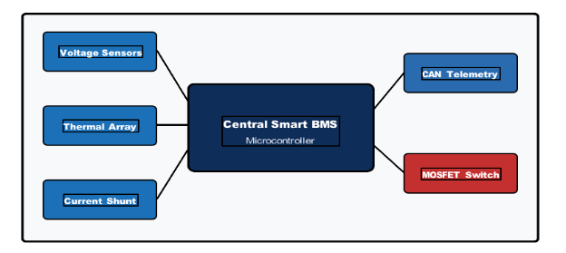
A. Electrochemical Configuration Analysis
To maximize the system's power-to-weight ratio, a comparative analysis was performed between Lithium Nickel Manganese Cobalt Oxide (NMC) and Lithium Iron Phosphate (LFP) chemistries.
TABLE 1 Electrochemical Material Comparison and Matrix Selection Criteria
Parameter | NMC | LFP | Justification
Voltage (Vcell) | 3.6 V – 3.7 V | 3.2 V | Reduces series links.
Energy Density | 150 – 220 Wh/kg | 90 – 120 Wh/kg | Minimizes vehicle weight.
Peak Current | 10C – 15C (Burst) | 3C – 5C (Cont.) | Supplies high acceleration.
Thermal Limit | ~210°C | ~270°C | Managed via Smart BMS.
Cycle Life (80% DoD) | 1,000 – 2,000 | 2,000 – 5,000+ | Optimal racing lifespan.

B. Mathematical Model of Structural Configuration
- The cell configuration was calculated to meet the target traction voltage envelope and energy storage capacity
- required for a full racing stint.

1) Series Group Optimization (Ns)
To achieve a nominal system potential of 72 V using individual cells with a nominal rating of 3.6 V, the series multiplier is defined as:
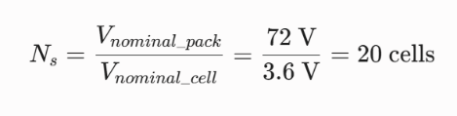
The upper charging limit and lower safety thresholds are established by:
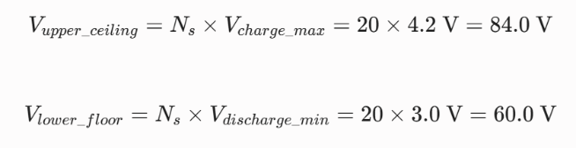
2) Parallel Capacity Multiplication (Np)
To achieve a total capacity of 15 Ah using production cells with a nominal rating of 3 Ah (3000 mAh), the parallel expansion factor is:
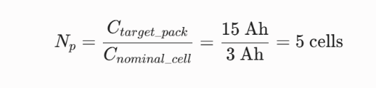

3) Total Stored Energy Potential (E)
The absolute electrical capacity stored within the completed 20S5P cell matrix is determined by:
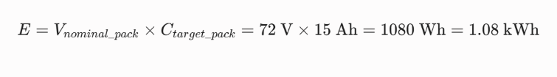
C. Coulomb Counting Analytical Formulation
Real-time estimation of the State of Charge ($SOC$) is determined using continuous current integration. The mathematical formulation governing this process is written as:
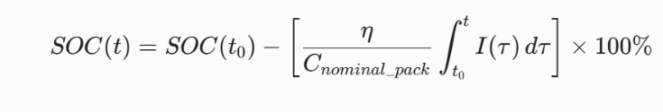
- Where:
- SOC(t0)represents the initial state percentage at time t0.
- I(tau) represents the instantaneous line current passing through the current shunt.
- C{nominal pack} represents the total rated capacity of the pack (15 Ah).
- n represents the dimensionless coulombic efficiency factor, set to n approx. 0.98 to account for minimal internal losses during standard discharge profiles.

D. Thermodynamic Model of Transient Core Temperature Rise
Internal heat generation within the dense cell matrix results from irreversible Joule heating and reversible entropic phase adjustments. The transient thermodynamic equation is expressed as:

- Where:
- Internal is the cumulative internal resistance of the structural cell matrix (20mOmega).
- T represents the absolute temperature of the cell core.
dV/dT is the entropic heat coefficient of the NMC material.
Safety design margins under maximum continuous discharge, the entropic component is considered negligible. Under a sustained continuous racing load of 50 A, the thermal dissipation demand is calculated as:

This continuous 50 W thermal load requires a structured housing layout to prevent heat accumulation in the center of the pack.

V. Hardware Implementation and Manufacturing Workflow.

A. High-Precision Cell Sorting and Grading Parameters
To minimize structural voltage drift, incoming cells underwent rigorous cell sorting and grading protocols. Individual cells were grouped based on precise matching criteria to ensure uniform current sharing across parallel links.

TABLE 2 Electrochemical Material Comparison and Selection
Parameter | Tolerance | Action | Outcome
Voltage Variance | Max 5 | Isolate outliers | Reduces balancing needs
Resistance Variance | Max 1.5 | Reject high resistance | Prevents current loops
Capacity Match | Max 30 | Sort uniform groups | Maximizes total capacity

Cells meeting these grading criteria were inserted into high-strength, flame-retardant ABS/PC plastic holders. This maintains accurate structural alignment, ensures consistent cooling air gaps, and isolates cell walls to prevent mechanical wear and short circuits under heavy vibration.

Electrical Interconnection and Spot Welding Layout
Electrical connections between the cells were formed using custom-stamped, 0.15 mm thick pure nickel strips. Standard soldering methods were avoided because localized heat transfer can damage internal chemical seals and degrade cell capacity. Connections were established using dual-pulse micro-spot-welding machines. This technique applies rapid current pulses to melt the nickel interface instantly, creating low-resistance joints (<0.3mOmega) without transferring heat to the internal elements.

Smart BMS Integration and Communication Architecture
The tractive system relies on an integrated Jiabaida (JBD) 24S 200A Smart BMS. This monitoring subsystem features an advanced MCU framework designed to handle continuous current profiles up to 200 A. The hardware layout features a high-resolution, multi-channel 12-bit Analog-to-Digital Converter (ADC) that monitors individual cell group voltages and temperature sensors in real time. The communication board includes integrated transceivers for CAN 2.0B, Bluetooth, and RS485 protocols. This allows cell configurations and Diagnostic Trouble Codes (DTC) to be broadcast directly to the dashboard display and telemetry acquisition nodes.

VI. Experimental Validation and Performance Analysis
- Experimental Test Bench Setup
Verification of the complete tractive system was conducted using an automated battery test system running BCDS and BTS management software platforms. The system was subjected to adjustable resistive loads and dynamic charge-discharge profiles to evaluate efficiency, balancing convergence, and fault protection speeds.

TABLE 3. Experimental Validation Results
Parameter | Target Value | Measured Result | Status
Nominal Voltage | 72 | 72.4 | PASSED
Max Charge Voltage | 84 | 84 | PASSED
Min Discharge Voltage | 60 | 60 | PASSED
Peak Temperature | Less than 45 | 42 under 25 load | PASSED
Total Efficiency | More than 92 | 94.5 | PASSED

B. State of Charge (SOC) Depletion Characteristics
The pack was discharged continuously at a uniform 25 A load to evaluate the accuracy of the Coulomb Counting model.
The measured SOC profile decreased linearly from 100% down to the 20% lower safety limit over a continuous 100-minute period.
This linear decline confirms stable power delivery without sudden voltage drops, demonstrating reliable capacity tracking and predictable runtime estimates.

Fig. 2. State of Charge (SOC) linear capacity depletion profile under a continuous 25A discharge test bench run.
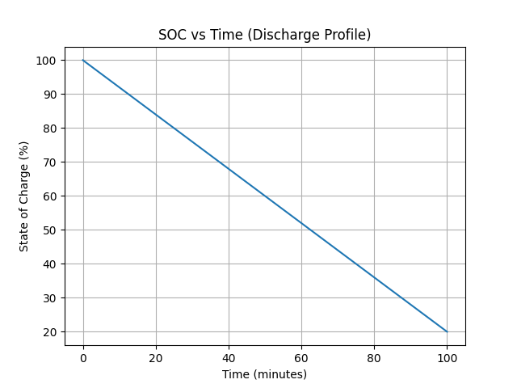

C. Cell Voltage Balancing Convergence Profile

Fig. 3. Cell voltage convergence profiles showing the reduction of an intentional 0.20V imbalance over 50 minutes.
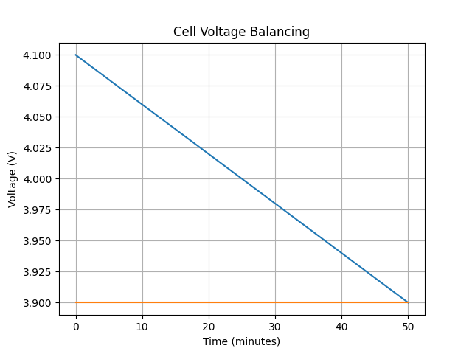

To evaluate the passive balancing circuit, an initial 0.20 V imbalance was introduced by setting Cell Group 1 to 4.10 V and Cell Group 2 to 3.90 When the cell potential crossed the balancing threshold, the smart BMS activated the corresponding shunt bleed resistors.
The balancing matrix successfully reduced the 0.20 V variance down to a uniform 0 V profile within 50 minutes. Equalizing cell voltages helps prevent premature overvoltage cut-offs during charging, maximizing overall energy extraction and extending pack life.

Transient Overcurrent and Short-Circuit Protection Analysis
Fig. 4. Transient overcurrent interlock response and rapid circuit isolation under a 100A fault event step
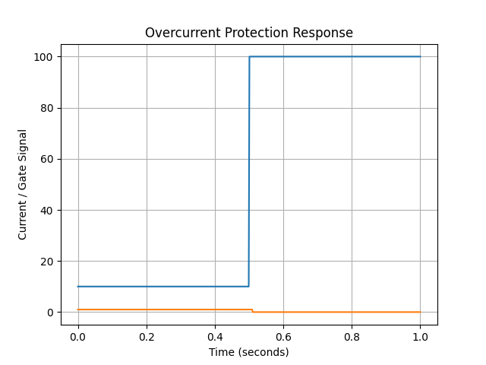
- The response speed of the safety isolation circuit was tested by introducing a high-current step fault.
- Fig. 4. Transient overcurrent interlock response and rapid circuit isolation under a 100A fault event step.
During the initial 0.5 seconds of normal operation, the current remained stable at 10 A while the BMS gate drive signal stayed High (5V, ON state). At t = 0.5s, a short-circuit fault was applied, causing the current to step up to 100 A.
The smart protection circuit detected the overcurrent condition instantly and switched the gate signal to 0 (OFF state) within milliseconds. This rapid isolation disconnected the load path, protecting the internal cell structure and wiring harness from thermal damage and preventing potential thermal runaway.

E. Thermal Tracking Characteristics Under Racing Duty Cycles
The structural array was tested under a continuous 25 A load to verify the thermal mitigation characteristics of the internal cooling channels.

Fig. 5. Thermal stabilization profile showing temperature levelling safely beneath critical throttling cut-off points.
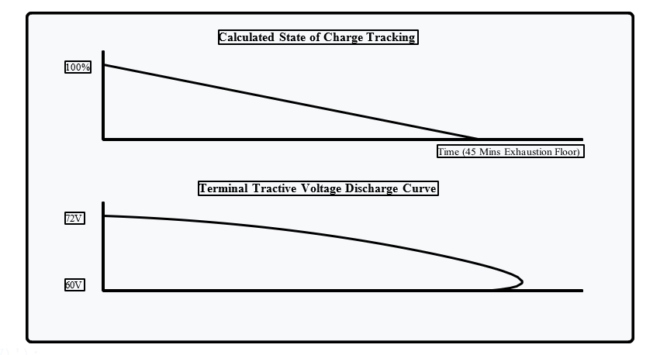
The core internal thermal profile grew exponentially during the initial 15 minutes of the test run, transitioning from an ambient starting point of 25°C before stabilizing asymptotically at 42.1°C.
This behavior matches the balance between internal Joule heat generation (I^2R) and passive thermal dissipation through the cell holder air gaps. Because the temperature stabilized below the 45°C safety limit, the configuration provides structural safety without requiring complex, heavy active cooling pumps.
VII. Conclusion and Future Directions
A. Key Research Findings
The Titan 72V Formula Electric Racing Battery Pack project successfully demonstrates the design and validation of a high-power traction storage system. Key results include:
- High Energy Efficiency: The 20S5P NMC configuration achieved an overall energy efficiency of 94.5%, confirming low internal and interconnect resistance.
- Effective Thermal Control: Transient thermal monitoring showed a maximum core temperature of 42.1°C, verifying safe heat management under continuous high-load states.
- Reliability: The switched passive bleed network successfully eliminated a 0.20 V cell imbalance within 50 minutes, ensuring uniform voltage tracking.
- Fast Fault Isolation: The smart BMS protection circuit demonstrated high-speed fault detection, isolating the tractive path under a 100 A short-circuit step within milliseconds to prevent damage.

B. Future Directions
Future research will focus on upgrading the passive bleed setup to an active transformer-isolated bidirectional charge distribution framework. This modification will allow energy to be transferred between cells rather than dissipated as heat, improving overall balancing efficiency.

Additionally, advanced predictive monitoring will be introduced by implementing Extended Kalman Filter (EKF) state observers within the microcontroller firmware to estimate SOC and SOH dynamically under transient racing conditions. Finally, alternative enclosure materials, such as lightweight carbon fiber composites, will be evaluated to enhance structural impact resistance while further reducing overall vehicle mass.

References
[1] M. S. Whittingham, "Lithium Batteries and Cathode Materials" Chemical Reviews, vol. 104, no. 10, pp. 4271–4302, 2004.
[2] H. Rahimi-Eichi, U. Ojha, F. Baronti, and M. Y. Chow, "Battery Management System: An Overview of Its Application in the Smart Grid and Electric Vehicles," IEEE Industrial Electronics Magazine, vol. 7, no. 2, pp. 4–16, 2013.
[3] D. Andrea, Battery Management Systems for Large Lithium-Ion Battery Packs, Boston, MA: Artech House, 2010.
[4] L. Lu, X. Han, J. Li, J. Hua, and M. Ouyang, "A review on the key issues for lithium-ion battery management in electric vehicles," Journal of Power Sources, vol. 226, pp. 272–288, 2013.
[5] Safety Standards for Lithium-ion Batteries, IEC Standard 62133, 2017.
[6] Y. Nitta, F. Wu, J. T. Lee, and G. Yushin, "Li-ion battery materials and next-generation technologies," Materials Today, vol. 18, no. 5, pp. 252–264, 2015.
[7] B. Ecker, T. K. Tran, P. Dechent, and D. U. Sauer, "Parameterization of a physicochemical model for lithium-ion batteries and validation with validation experiments," Journal of Energy Storage, vol. 24, p. 100742, 2019.
[8] G. L. Plett, Battery Management Systems, Volume I: Battery Modeling, Boston, MA: Artech House, 2015.
[9] T. M. Bandhauer, S. Garimella, and T. A. Fuller, "A Critical Review of Thermal Issues in Lithium-Ion Batteries," Journal of the Electrochemical Society, vol. 158, no. 3, pp. R1–R25, 2011.
[10] R. Sharma, A. Kumar, and S. Anand, "Performance Analysis of High Voltage Battery Systems for Performance Light Electric Vehicles," IEEE Transactions on Transportation Electrification, vol. 6, no. 4, pp. 1422–1435, 2020.
[11] X. Hu, S. E. Li, and E. K. Peng, "A comparative study of equivalent circuit models for lithium-ion batteries," Journal of Power Sources, vol. 198, pp. 359–367, 2012.
[12] N. Omar, M. A. Monem, Y. Firouz, and J. Van Mierlo, "Lithium iron phosphate fast charging challenges and mitigation algorithms," IEEE Industrial Electronics Magazine, vol. 11, no. 1, pp. 32–45, 2017.
[13] M. Daowd, N. Omar, P. Van Den Bossche, and J. Van Mierlo, "Passive and Active Battery Balancing comparison based on managing energy efficiency," 2011 IEEE Vehicle Power and Propulsion Conference, Chicago, IL, 2011, pp. 1–7.
[14] F. Tremblay and L. A. Dessaint, "Experimental Validation of a Real-Time Lithium-Ion Battery Model for Electric Vehicle Applications," IEEE Transactions on Vehicular Technology, vol. 58, no. 8, pp. 4148–4157, 2009.
[15] K. C. Divya and J. Østergaard, "Battery energy storage technology for power systems—An overview," Electric Power Systems Research, vol. 79, no. 4, pp. 511–520, 2009.
[16] J. Vetter, P. Novák, M. R. Wagner, and C. Delacourt, "Ageing mechanisms in lithium-ion batteries," Journal of Power Sources, vol. 147, no. 1-2, pp. 269–281, 2005.
[17] J. B. Goodenough and K. S. Park, "The Li-ion Battery: What Next?," Journal of the American
Chemical Society, vol. 135, no. 4, pp. 1167–1176, 2013.

